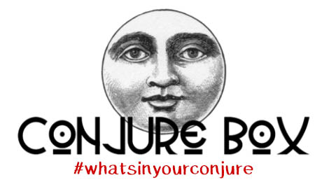
Welcome to a new era of modern conjure!
What’s Inside

Louisiana Lucky Green Rice: Lucky green rice is used to attract luck and prosperity. Our Louisiana Lucky Green Rice is handcrafted from aromatic Jasmine rice that is hand-dyed a rich green and supercharged with real shredded money and Hoyt's Cologne and is great for use in gris gris and mojo bags. Or, sprinkle a little on your front porch to draw in good luck.

Alfalfa: Used for prosperity, good luck, gambling luck, business success, financial security, and to prevent poverty and money troubles. Carry some in your wallet, pocket or purse to maintain a positive cash flow.

Money Drawing Gris Gris: Voodoo Mama's Money-Drawing Gris Gris Bags are used in Southern folk traditions when the goal is to improve the flow of money and to draw more of it into your life.

Give Me Money Conjure Oil: Rub some in your hands then touch the person who you want money from. If the person who owes you is far then put some on a letter and send it to them. It never fails! Use Voodoo Mama's Give Me Money Oil as a dressing oil for fixing candles for spells, added to the bath, or worn as a magical perfume.

Selenite Wand: A sun-loving mineral, Selenite is good for healing, harmonizing, and balancing, Place on top of the head to clear confusion. Place on a windowsill in a room to clear away negative energy. Rub over your body to erase negativity.

Conjure Tip with Magic Seal from the 7th Book of Moses: A magickal tip from our Daily Conjure Tips archive for a Potted Plant Prosperity Spell.

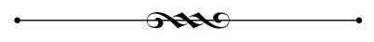

This Conjure Box has been lovingly prepared for you by:

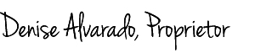

May the Blessings of the Seven African Powers be with you Always!

FOLLOW US:

Facebook: https://www.facebook.com/conjurebox
Pinterest: https://www.pinterest.com/voodoomama/conjure-box/
Instagram: https://www.instagram.com/conjurebox/
Twitter: https://twitter.com/ConjureBox1

